Bible Story Game
Three in a Row
Equipment
- 16 sheets of construction paper
- Masking tape
- 3 beanbags
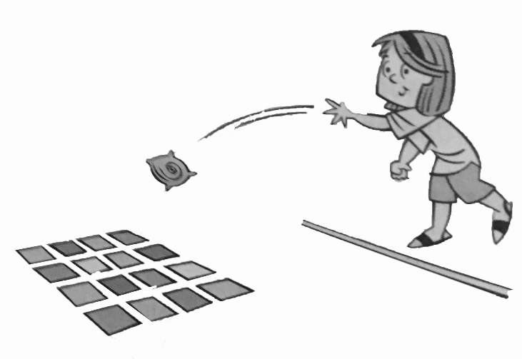

Preparation
- Set up construction paper and tape to floor in a grid pattern (see sketch). Use masking tape to make a line about 10 feet from the grid.
- Print list of questions (page 2)
Game
- Have children line up behind masking tape.
- Have children take turns throwing a beanbag onto the grid. The next child tosses a beanbag, trying to land it on a paper beside the first beanbag.
- When they land three in a row – vertically, horizontally or diagonally, the group is asked a question.
- Retrieve the beanbags and repeat.

Questions (True or False)
- The man in our story begged for food and money because he was blind. (True)
- Jesus said the man had sinned and that was why he was blinder (False)
- Jesus said the man was blind so that people could see God’s work in his life. (True)
- Jesus told the man to wipe the mud off his eyes with a special cloth. (False)
- The blind man could see again after he promised Jesus he would stop doing wrong things. (False)
- The Pharisees argued because some thought Jesus was a sinner for healing the man on the Sabbath. (True)
- The Pharisees asked the parent sof the man Jesus helped if he had really been blind. (True)
- The Pharisees all agreed that Jesus healed the blind man. (False)
- The Pharisees said the man who had been blind could not come to the synagogue anymore (True)
- The healed man believed Jesus is God’s promised Savior. (True)

