Memory Verse Game
Stack ‘Em Up
Equipment
- Small weighted objects (gravel, rice, metal washers)
- 6 empty soda cans
- Placemat
- Balls
- Scissors
- Duct tape
- Masking tape

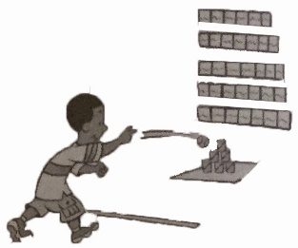

Preparation
- Print verse (page 2) and Stack Em cards (page 3 & 4).
- Cut apart verse cards.
- Tape cards in order on a wall.
- Place a few weighted objects in each soda can. Cover opening with duct tape.
- Put the placemat on the floor and stack cans on it in a pyramid.
- With masking tape, mark a line approximately 10 feet from the pyramid.
Game
- Have children line up behind masking tape.
- Have children take turns throwing a ball at the cans, trying to knock as many off the placemat as possible.
- Remove one verse card for each can that was completely knocked off the placement.
- Have the child recite the entire verse, including the missing words before the cans are restacked in a pyramid.
- Repeat steps 1-4 until all the words are removed.

